Language models



In this project you will learn the concepts behind “language models” – the sort of technology used in tools such as “ChatGPT”.

The use case for these technologies is often described as “Generative Artificial Intelligence” (or “Generative AI”): using artificial intelligence to create content – to “generate” new text, images, audio, video, etc.

You’ll learn the ideas behind how these technologies work by using language models to generate new text.

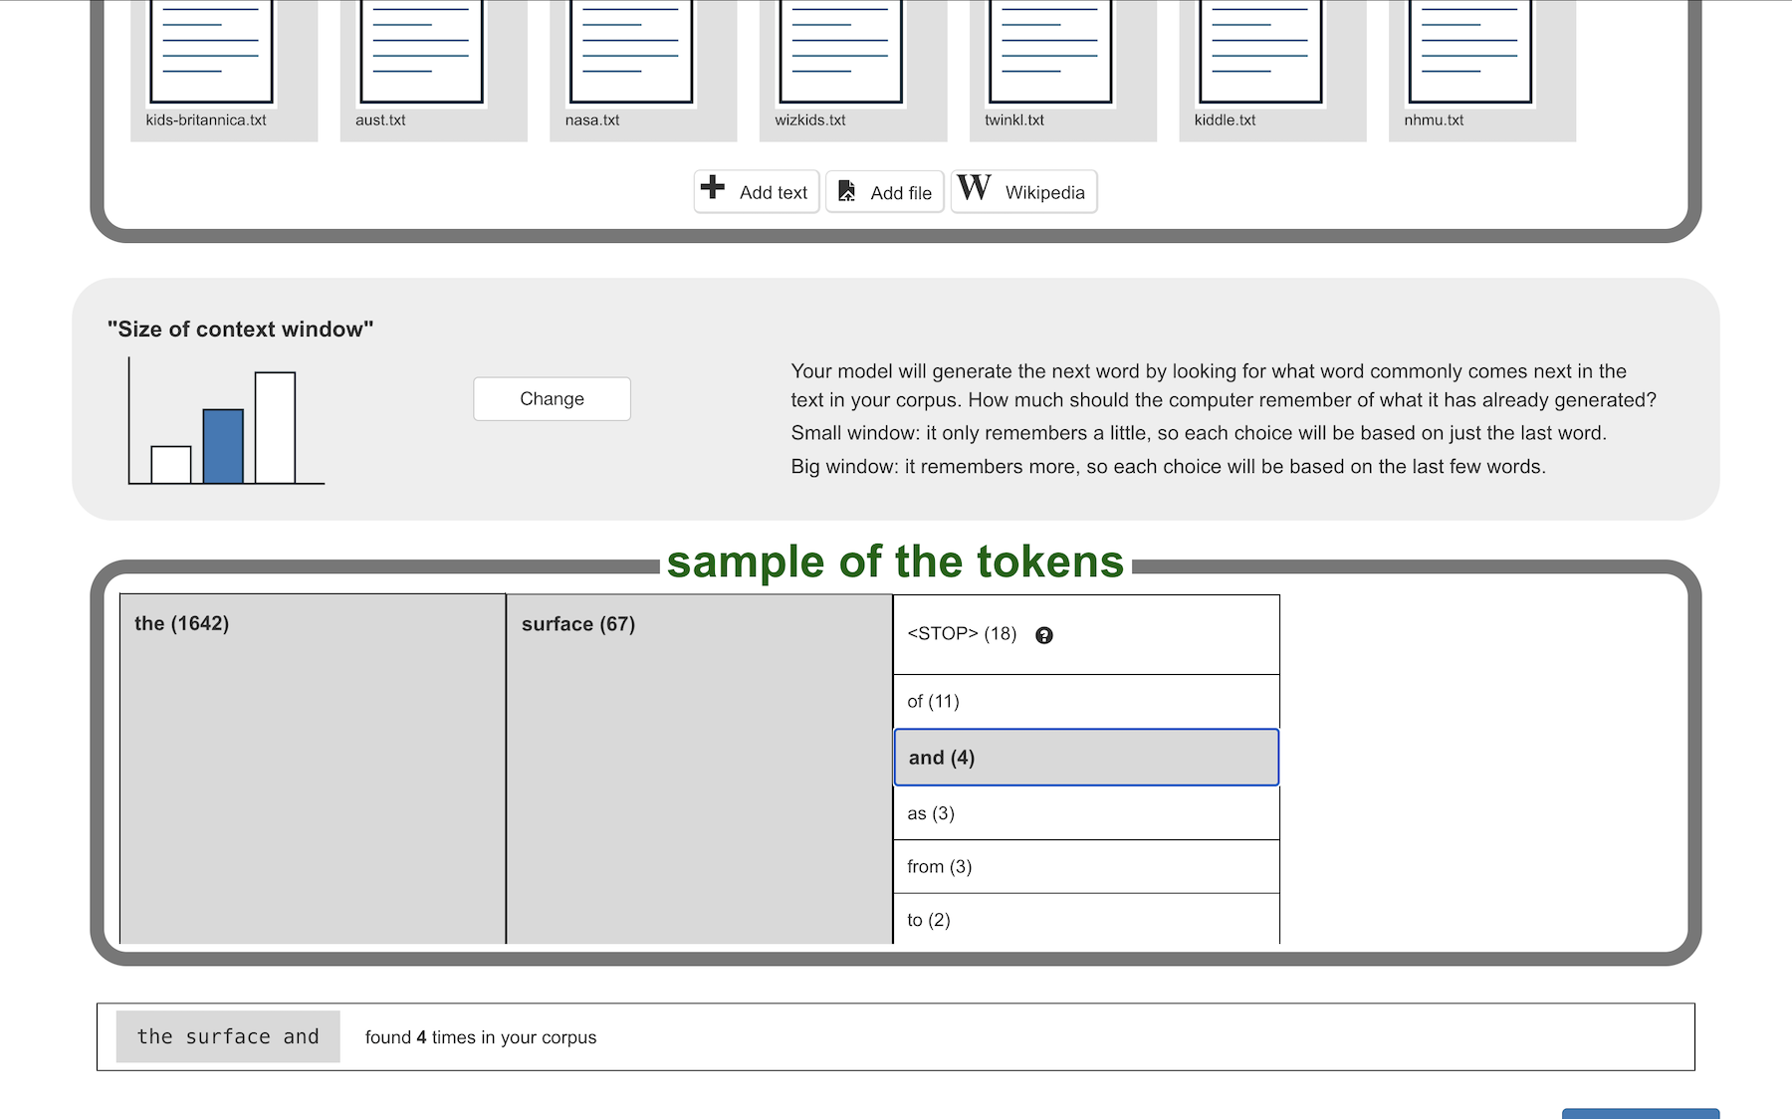

This project worksheet is licensed under a Creative Commons Attribution Non-Commercial Share-Alike License

http://creativecommons.org/licenses/by-nc-sa/4.0/

**What will you be doing?**

There are two stages to this project.

In the first stage, you will create a **“toy” language model**, that learns from text documents you choose for yourself. These are very simple, so you will be able to see everything that it is doing and how it works. This makes it a good way to learn the concepts behind how these technologies behave, however it will be so simple that it won’t generate very intelligent text.

In the second stage, you will use what you learn from creating a toy model to configure a real **“small” language model**, trained with millions of documents. This will let you start generating useful and interesting text.

**Stage 1 – Create a “toy” language model**

1. Choose a subject that you want your model to generate text about.  
   It should be something that it will be easy to find simple text about.   
   It can be a geography subject, like a famous river or mountain.   
   It can be a history subject, like the Romans or Vikings.   
   It can be a famous person, like a Queen or President.   
   *For the screenshots in this worksheet, I used “volcanos” as a subject – so my language model will try to generate text about volcanoes.*
2. Look for text about your subject.   
   Simple, child-friendly text will work best.   
   *For my volcano model, I found useful text in places like:  
   BBC Bitesize -* [*https://www.bbc.co.uk/bitesize/articles/zkvxvj6*](https://www.bbc.co.uk/bitesize/articles/zkvxvj6) *Encyclopaedia Britannica -* [*https://www.britannica.com/science/volcano*](https://www.britannica.com/science/volcano) *Wikipedia -* [*https://en.wikipedia.org/wiki/Volcano*](https://en.wikipedia.org/wiki/Volcano)
3. Save the text that you find in plain text (**.txt**) files  
   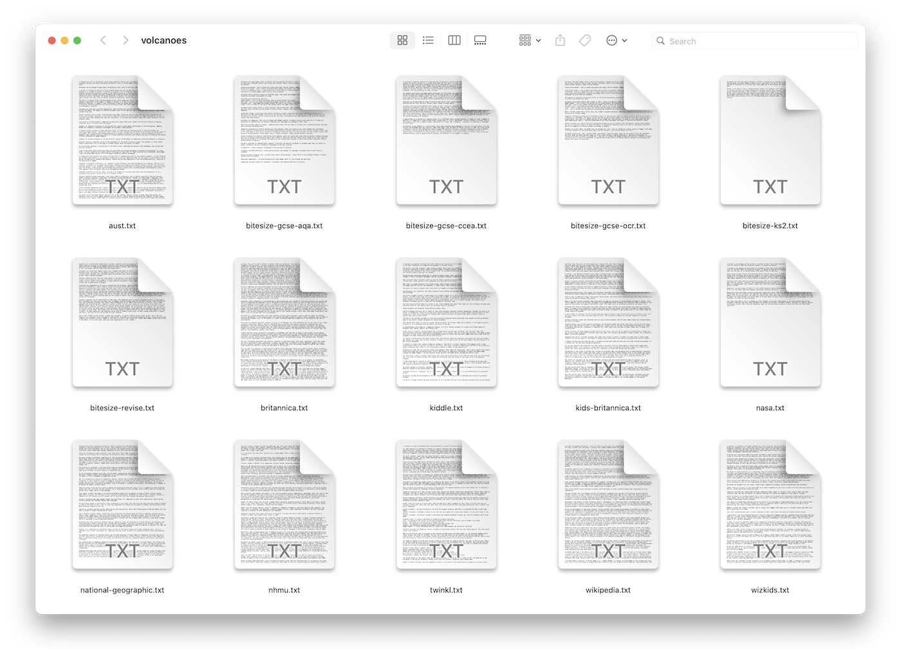
4. If you would like to save time by re-using my text files, you can download a zip file with all of them at:   
   <https://github.com/dalelane/volcanoes>   
   *If you do this, you should:  
   1) Unzip the zip file so you have a folder with txt files like above  
   2) Look through the files so you have an idea of what they contain*
5. Go to <https://machinelearningforkids.co.uk/>
6. Click on “**Get started**”
7. Click on “**Log In**” and type in your username and password  
   *If you can’t remember your username or password, ask your teacher or group leader to reset it for you.*
8. Click on “**Projects**” on the top menu bar
9. Click the **“+ Add a new project**” button.
10. Name your project and set it to learn how to generate text.   
    *I called my project “volcano expert” because I want it to generate text about volcanoes.   
    Choose a good name for your own project.*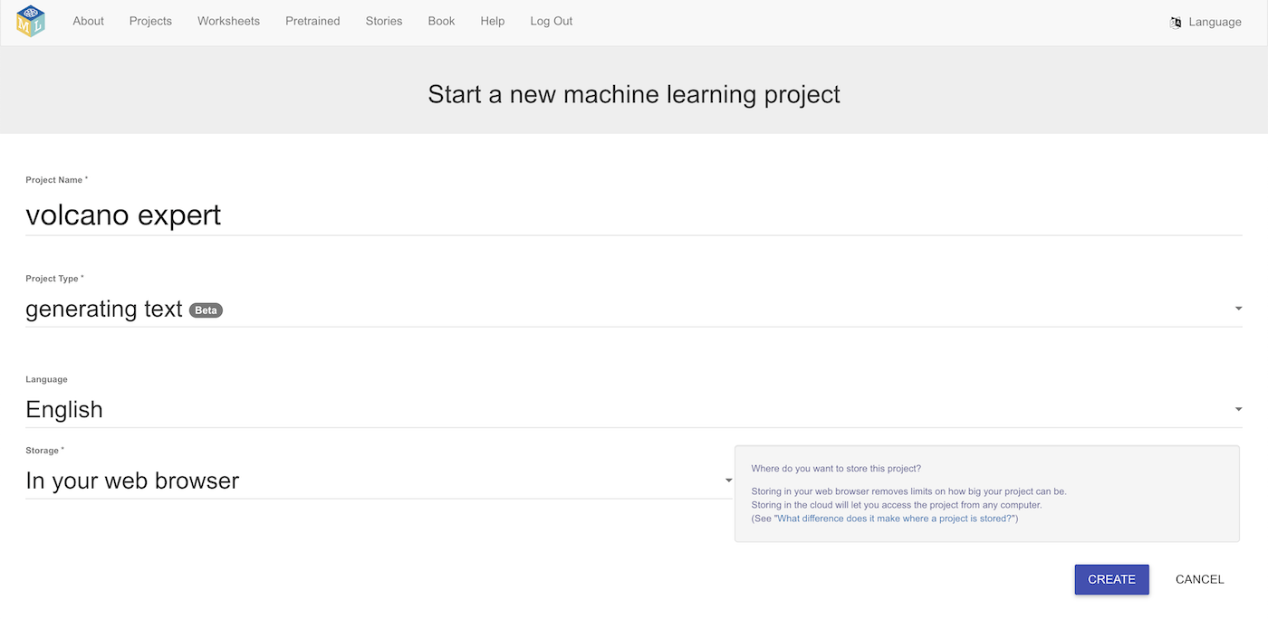
11. Click **Create**
12. You should see your new project in the projects list. Click on it.  
    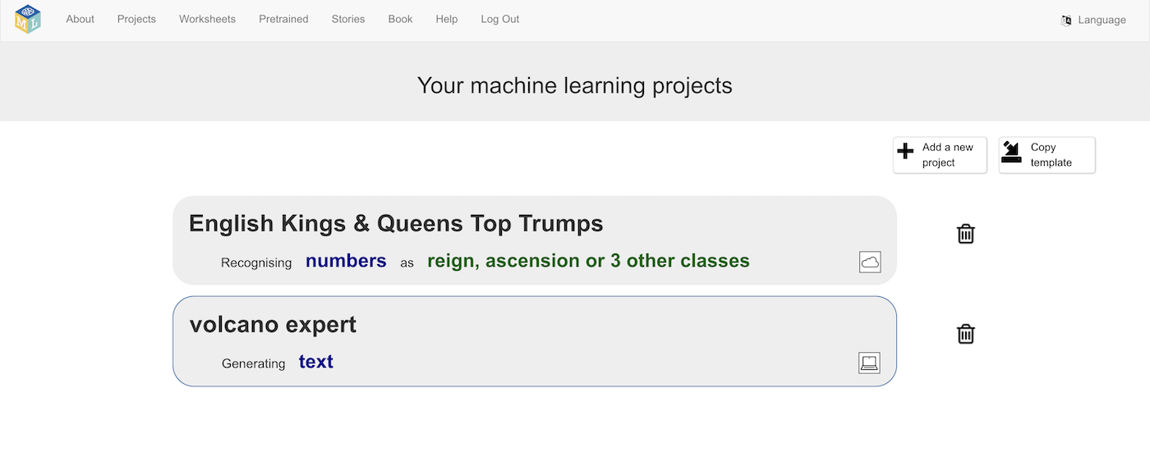
13. Click on **Toy** and then click **Next**
14. *You can add text by typing it into a window (****Add text****), or by choosing Wikipedia pages (****Wikipedia****).   
      
    We’ll be uploading files for this project, but you can try these other options as well if you like.*
15. Use **Add file** to upload the text files you’ve collected  
    *You can upload all of them at once if they are stored in the same folder*  
    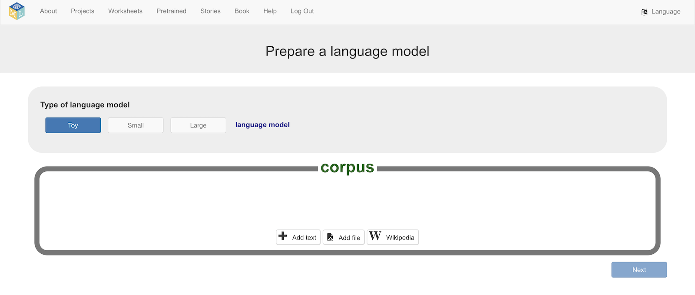
16. Click **Next***If you have collected a lot of text files, you might need to scroll in the “corpus” view to see some of them.*  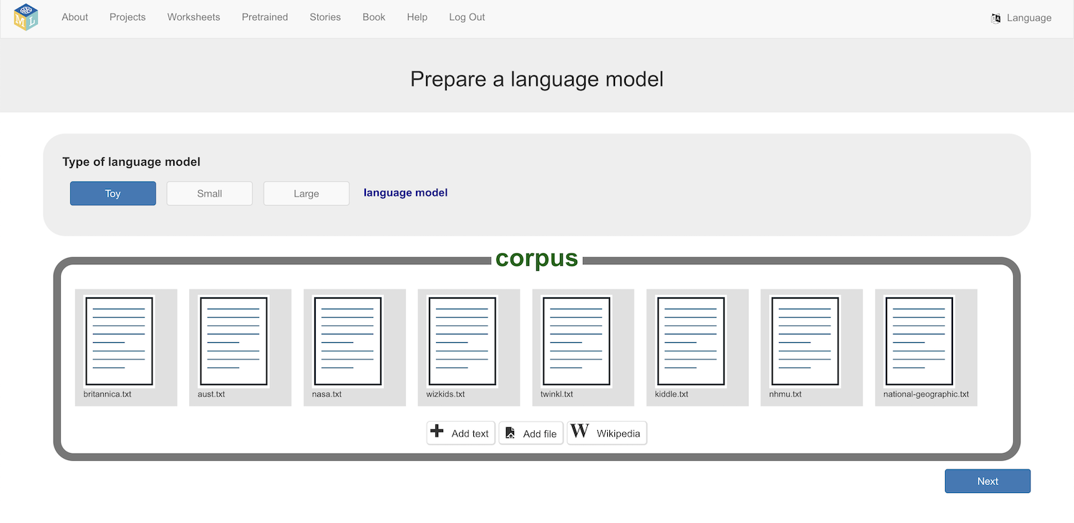
17. Click on **Change** until the bar graph shows a single highlighted bar  
    Then, click on **Next**  
    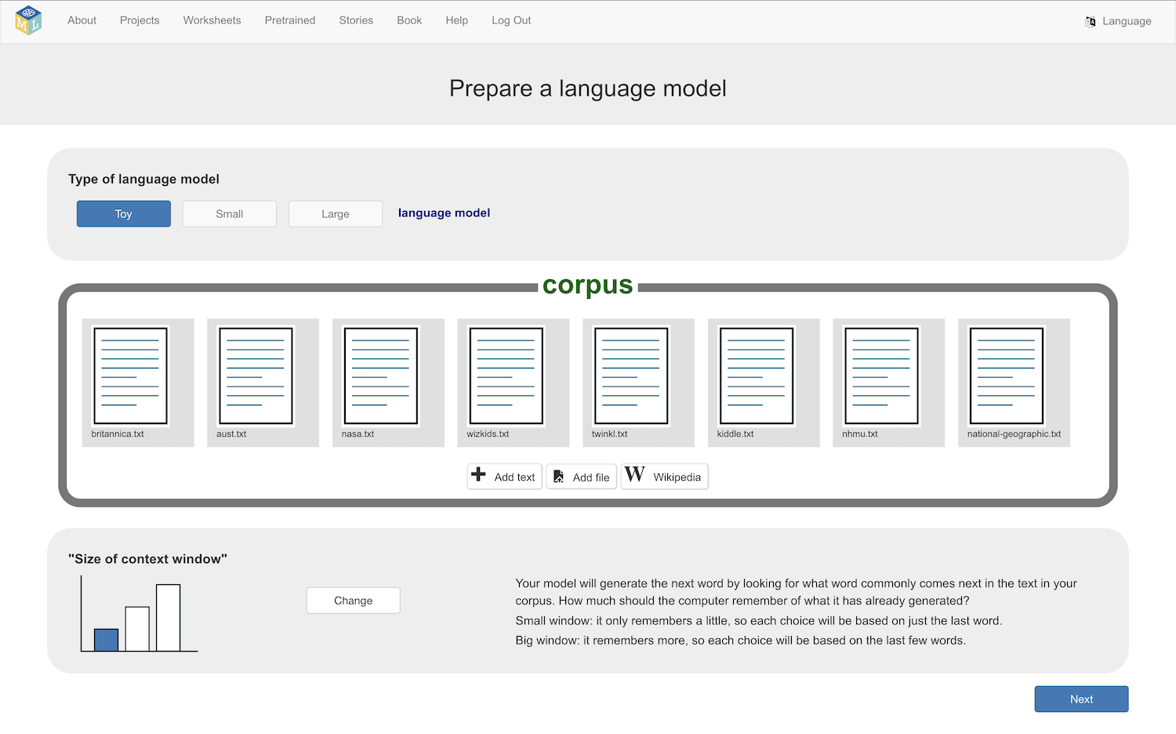

**What will the computer do now?**

The computer will go through the text that you’ve collected, and look for patterns in the sequences of words.

It counts how many times each word is followed by every other word.

For example, the word “**the**” is probably in your text somewhere. But what words come after “the”. For every word that comes after “the”, how many times does that happen?

Not all of these counts will be displayed, as that would be a very long list!

What you will see will be a small sample of some of what the computer has found. You will see the words that come up most often, and the words that follow those most frequently.

1. Look through the sample of tokens found in your text  
   *For example, the word “****the****” is found 1642 times in my documents  
   Of those times, 67 times the next word was “****surface****”  
   In other words, “****the surface****” was found 67 times in my text  
   53 times, the next word after “****the****” was “****volcano****”  
   In other words, “****the volcano****” was found 53 times in my text.*  
   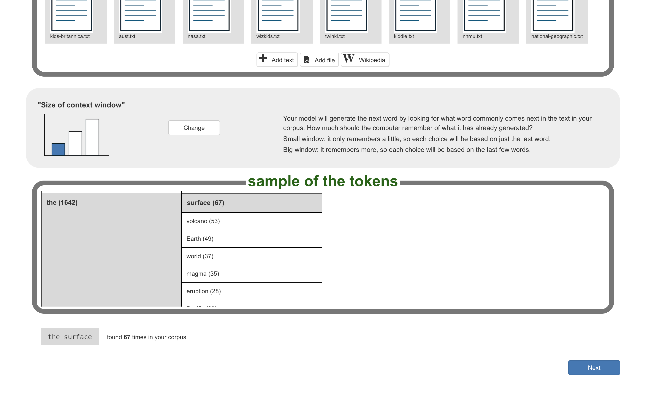
2. Scroll through the list of tokens from your text  
   Click on different tokens to see the counts for them.  
   *Was this what you would have expected the computer to find?*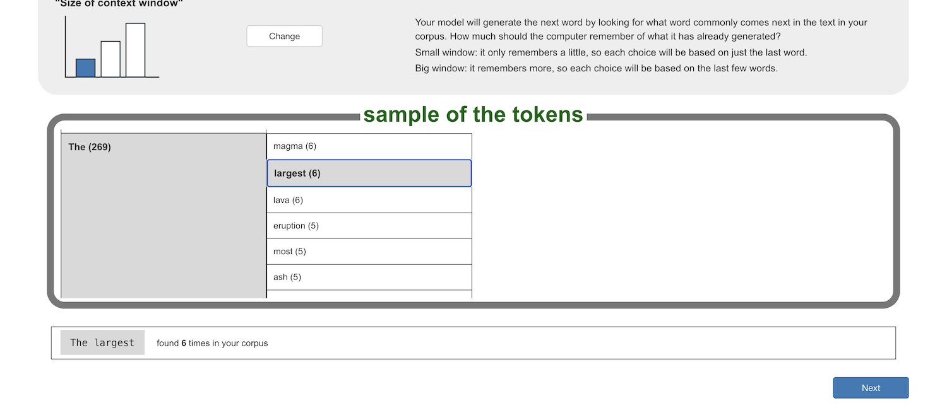

**What is the <STOP> token?**

This represents the end of a sentence. It is normally a full-stop (period), but it could be a question mark or an exclamation mark.

The computer counts how often these come after every word, in the same way that it counts how often other words come after every word.

For example, in my text, the word “volcano” was at the end of a sentence 42 times.   
  
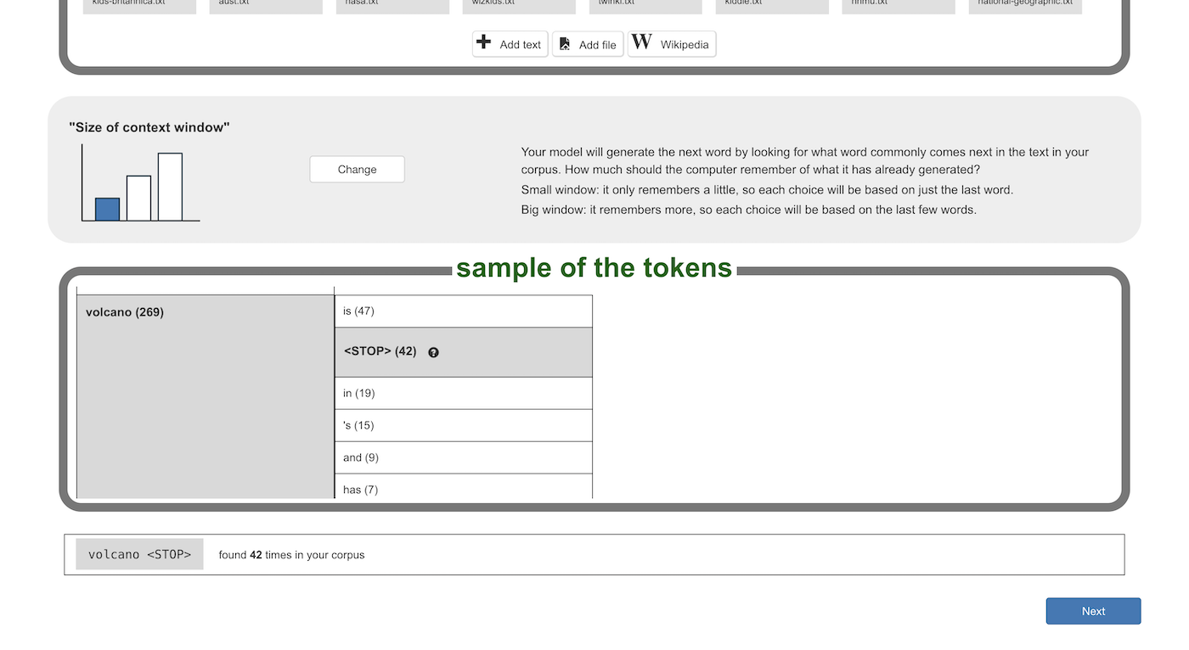

These patterns will be used to help the computer generate new text.

1. Find out what was the most common word in your text  
   *If the <STOP> token is the most common, find the next most common after that.*
2. Click **Next**

**How are these patterns used to generate text?**

For any word that the computer has found in your text, it now has a record of what words normally come next, and how often that happens.

It can use these patterns to generate new text, by choosing the next word from the words that it has seen can come next.

You will control how it uses these patterns to choose the next word.

1. The green bars show the probability that the computer will choose a word as the next word.   
   *For example, this shows that when the computer has the word “****the****” there is approximately a* ***15%*** *chance that it will choose “****surface****” as the next word.*   
   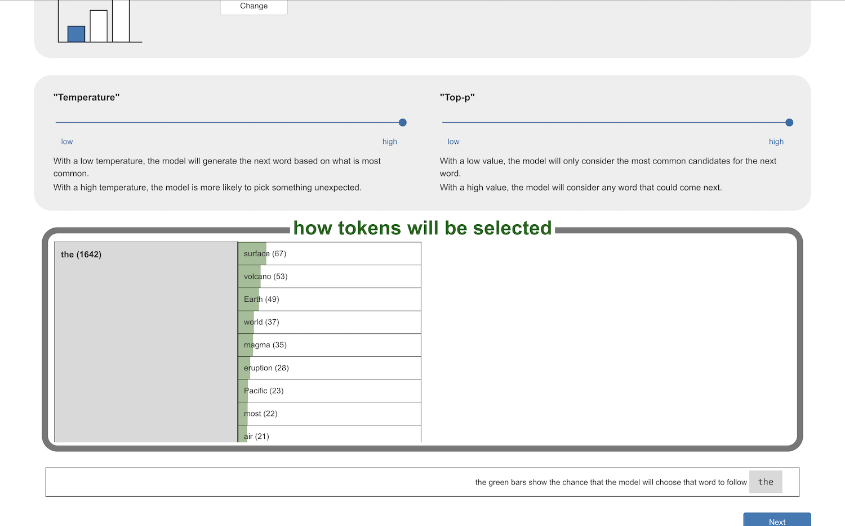
2. Adjust the **“Temperature”** and **“Top-p”** scroll bars  
   *How does this change the probabilities for each word?   
   Experiment with different values. Watch how the size of the green bars change. Can you understand what these scroll bars are doing?*

**“Top-P”**

“Top-P” describes which of the words that came next should be a candidate.

With a high “Top-P” value, every word that has ever come next is a candidate.

With a low “Top-P” value, the less frequent words are removed as candidates. You should see them go grey as they are removed from the list of words that the computer could choose to go next.

How do you want the computer to generate new text?

* Do you want to choose the next word from what comes next very often? (keep “Top-P” low)
* Or do you want it to have anything that has ever come next as an option? (choose a high “Top-P”)

**“Temperature”**

The longer the green bar, the higher probability that the computer will choose that word to come next. The probability is controlled by the “temperature”.

With a high “temperature”, all the candidate words have a chance. It has a higher probability of picking the more common ones, but they all get a chance.

If you lower the “temperature”, you reduce the probability of picking the less common ones, and increase the chance that the computer will pick a more common word.

How do you want the computer to generate new text?

* Do you want to almost always pick the next word that came next the most often in the documents? (choose a high “temperature”)
* Or do you want it to sometimes pick a next word that is a bit more unusual? (choose a low “temperature”)

1. When you understand what the sliders are doing, click **Next**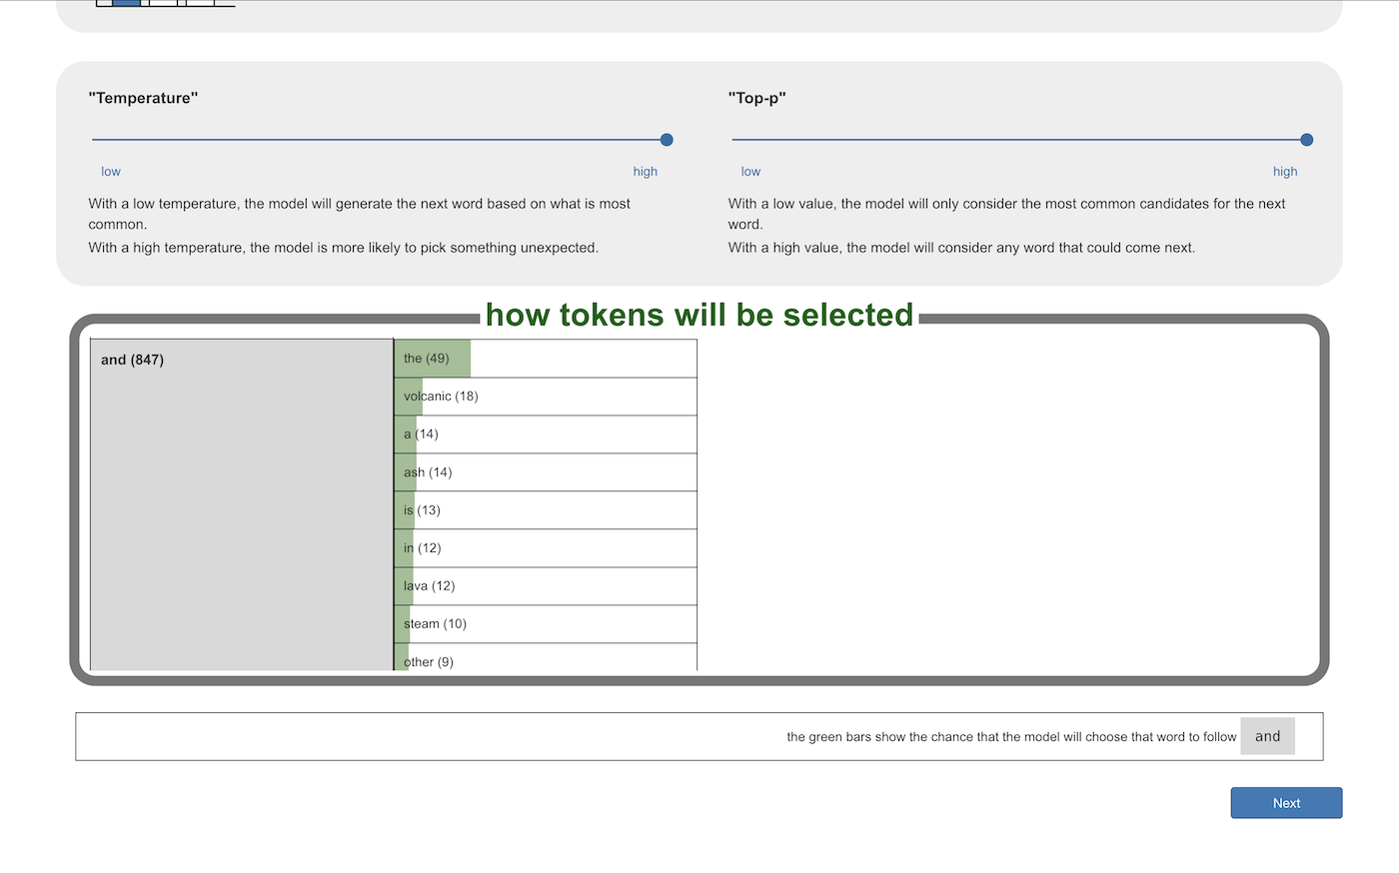
2. Generate some text!  
   *Enter the most common word from your documents into* ***Prompt*** *and then click on* ***Generate***   
   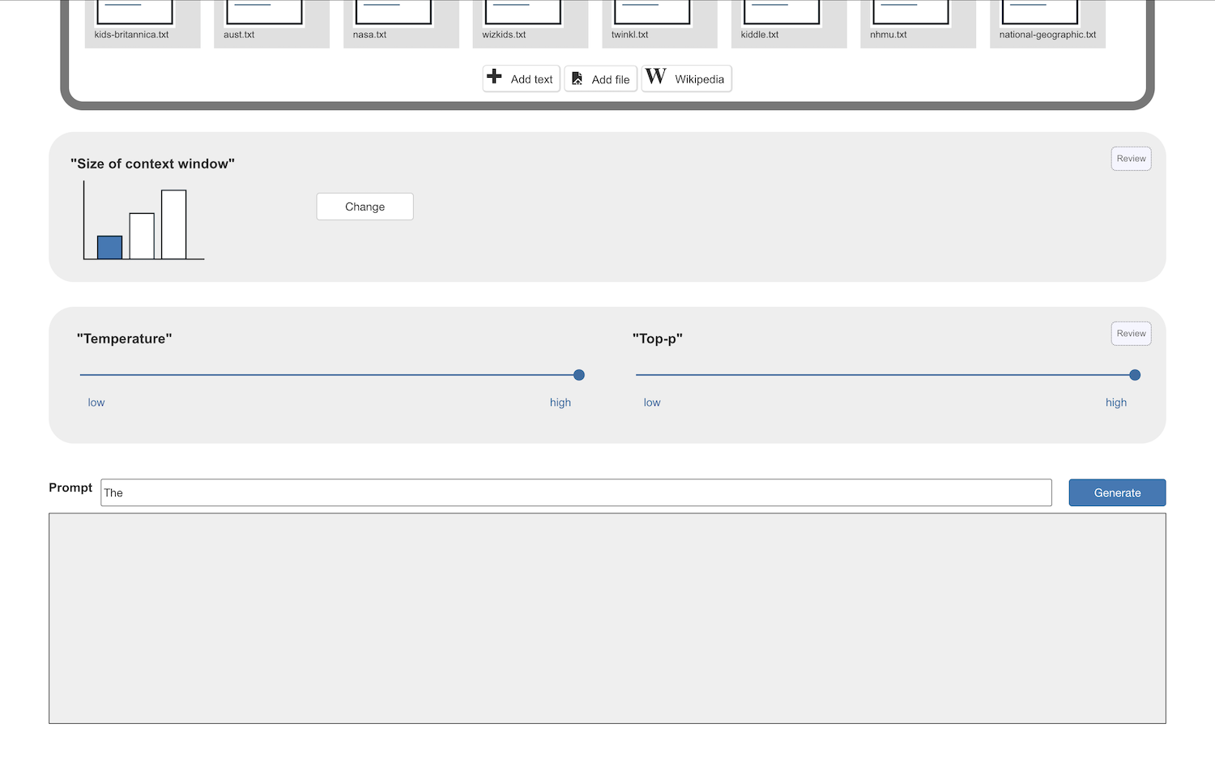
3. There is some randomness involved. Click **Generate** again to generate new text from the same starting word.  
   *How much randomness will depend on the values you chose for “Temperature” and “Top-P”.*
4. Click on any word in the generated text to see why the computer chose it as the next word.  
   *Try clicking on a few different words to understand what the computer has done.*  
   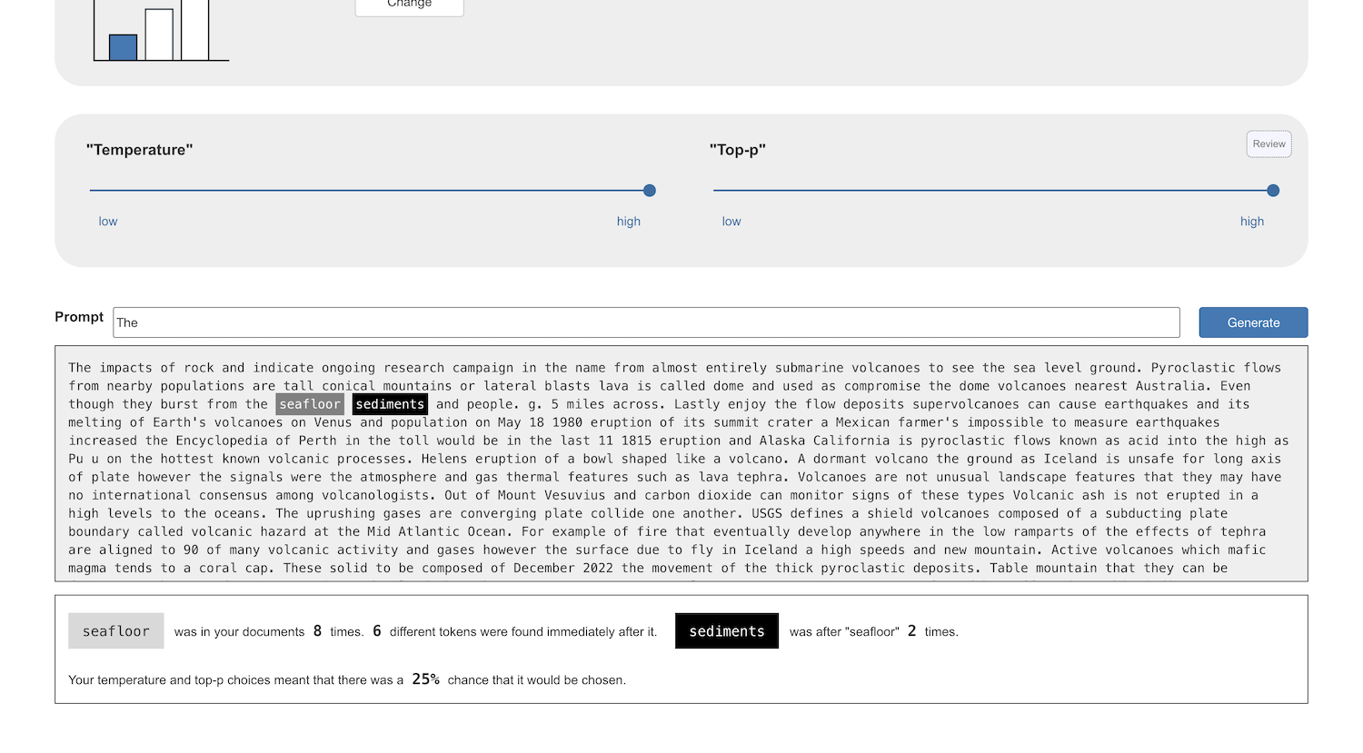
5. Adjust the “Temperature” and “Top-P” values and see how that affects the text that the computer generates  
   *Very low temperature and top-p values will likely result in the computer getting into a loop.  
   If you click on the generated word, you will likely see that by reducing the list of candidates so much, you may have only left the computer with one word to choose from as the next word.*   
   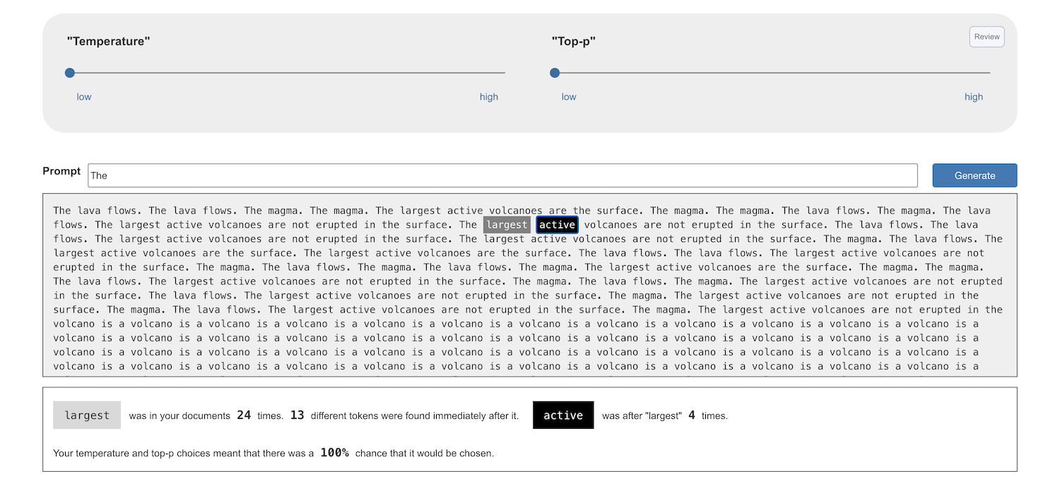

**Can you get the computer to generate sensible text?**

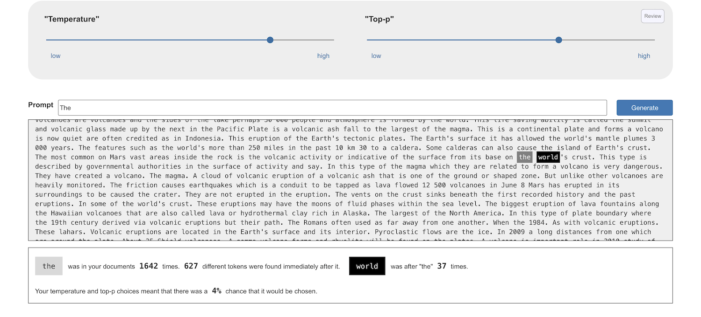

The text you are generating is likely nonsensical.

Consider this word the computer generated about volcanoes for me:

**The most common on Mars vast areas inside the rock is the volcanic activity or indicative of the surface from its base on the world's crust.**

Clicking on “**world**”, I can see that the only thing that was used to choose that word was the word “**the**” that came before.

The fact that the sentence started by talking about Mars was not used. By the time the computer had reached the end of the sentence, the start of the sentence was no longer in it’s memory.

This is a big reason why the text the computer is generating doesn’t make much sense.

Next, you will increase the length of the context that the computer is using to consider the next word, to see how this can help.

1. Click on the **Review** button in the **“Size of context window”** section to return to this step.   
   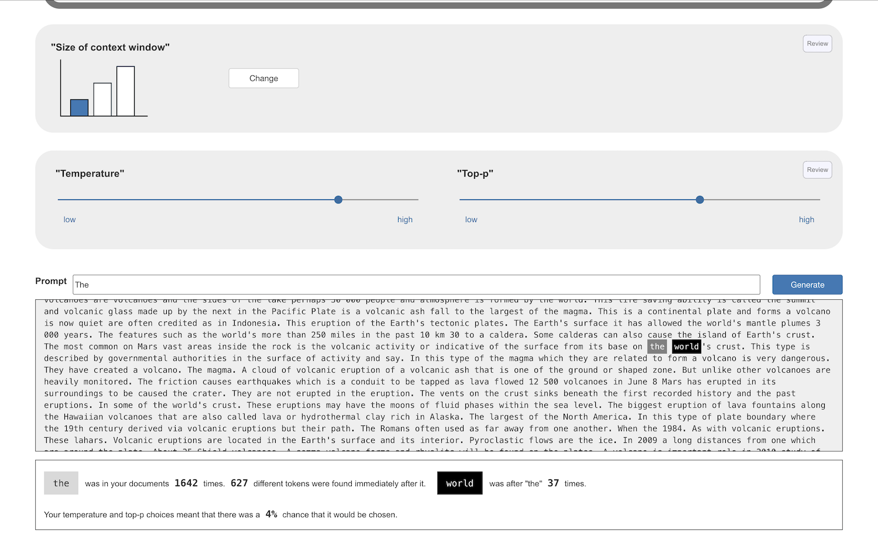
2. Click on **Change** to highlight the second bar in the bar chart  
   Then click **Next**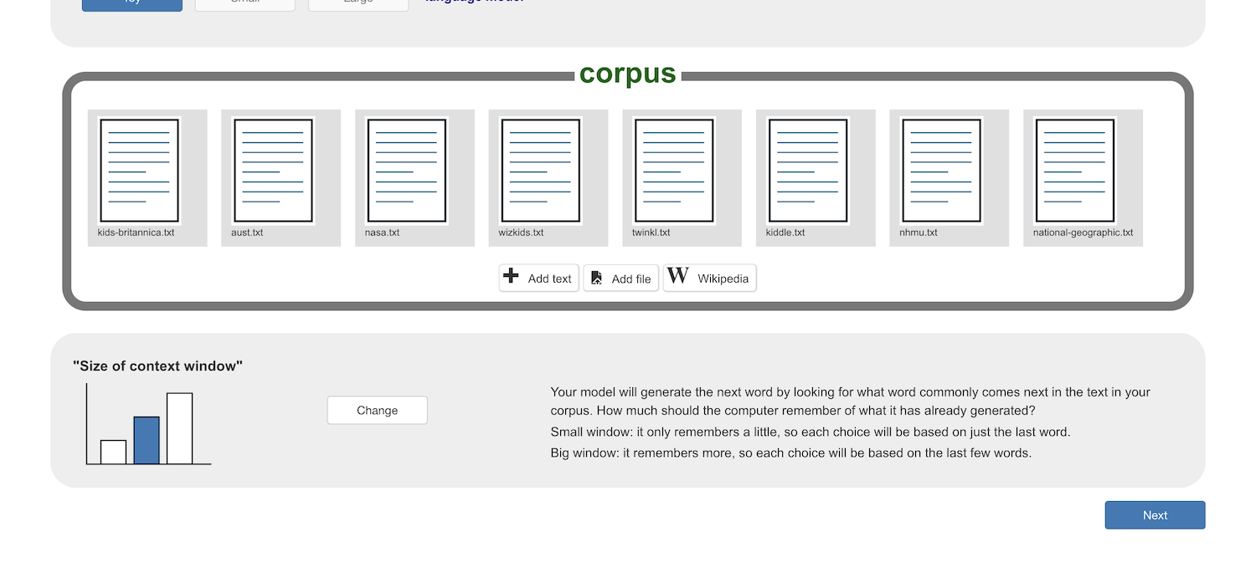
3. Look through the sample of the tokens found in your documents as you did before.
4. This time, the computer has counted the number of times that words follow pairs of words.  
   *For example, in my text, “****the surface****” was found 67 times.  
   11 of those times, the next word was “****of****”.   
   In other words, “****the surface of****” was found 11 times in my text.*   
   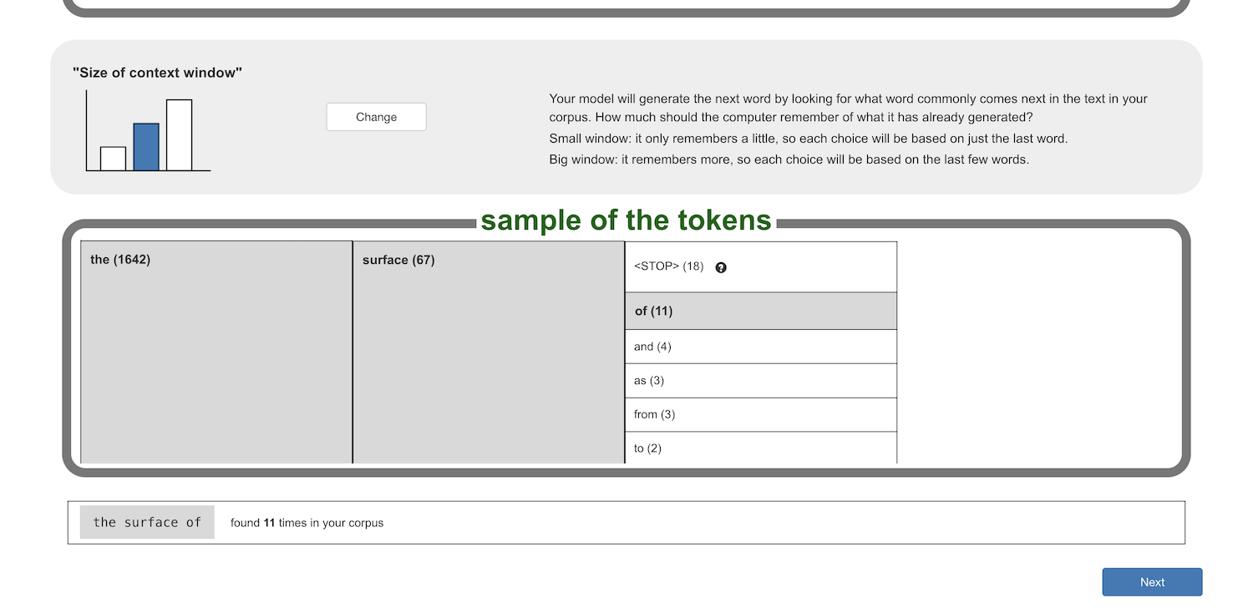
5. Find the most common two-word-sequence in your text  
   *If the <STOP> token is in the most common sequence, find the next most common after that.*
6. Click **Next** and try generating text.   
   *You will need to give the computer two words to start it off, as this time it is looking for patterns for what word comes next after two tokens.  
   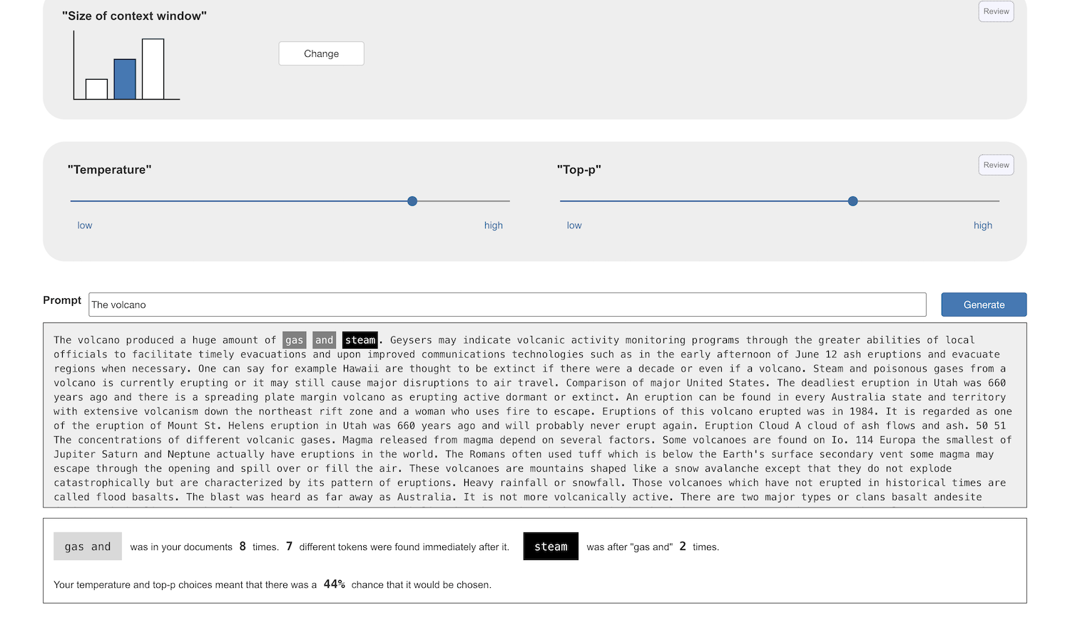*
7. Try experimenting with the “Temperature” and “Top-P” values again  
   *How does this impact the text that the computer generates?*
8. Increase the context window again   
   Click on **Review** in the “Size of context window” section  
   Click on **Change** to highlight the third bar in the bar chart  
   Click **Next**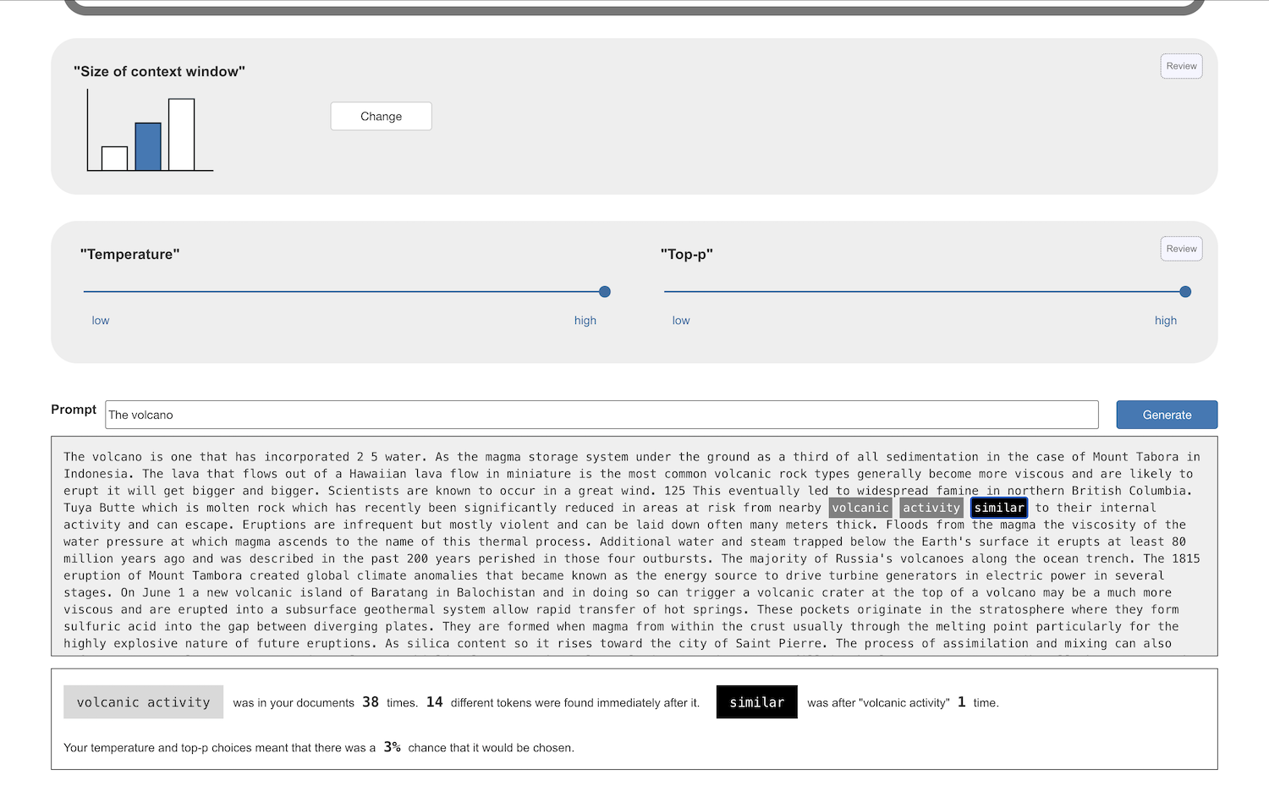
9. Review the tokens that the computer has found this time  
   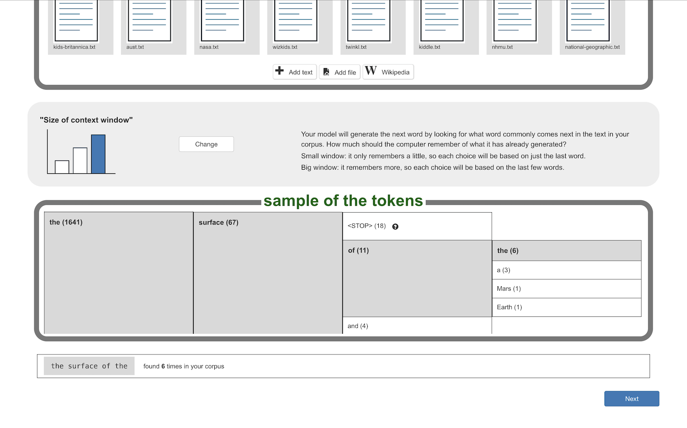  
   *In my text, “****the surface of****” was found 11 times.   
   Of those times, “****the****” was the next word 6 times.*
10. Look at the numbers of times these 3-word sequences were found  
    Look at the number of times the computer found words that followed these three-word sequences  
    *The counts are displayed in parentheses – for example:* ***the (6)*** *You will likely see much smaller counts with these longer word sequences then you’ve seen before.*
11. Find the most common three-word-sequence in your text  
    *If the <STOP> token is in the most common sequence, find the next most common after that.*
12. Generate some text  
    *You can use the most common three-word sequence as a starting prompt*  
    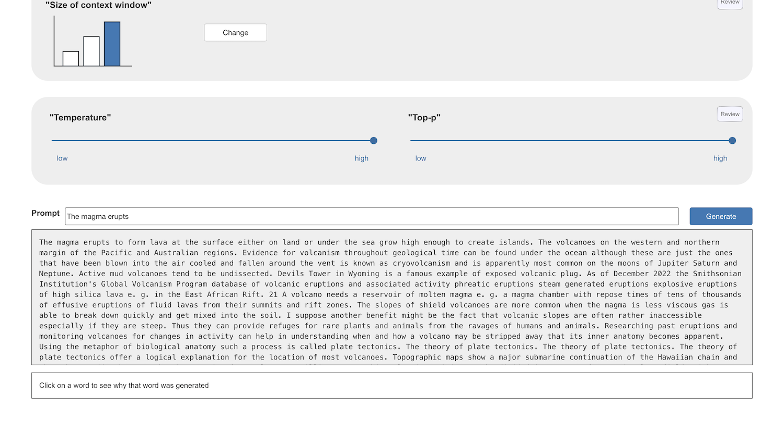
13. Experiment with different **“Temperature”** and **“Top-P”** values
14. Experiment with different starting words
15. Compare the text that is generated now with the text that you saw generated before.   
    *Does this text look more sensible?*

**Increasing word sequence lengths with a small text corpus**

Clicking on a word shows that the computer is reproducing sections from the documents that I collected.

For example:  
**Over time the formations created by submarine volcanoes may become so large that they break the ocean surface…**  
  
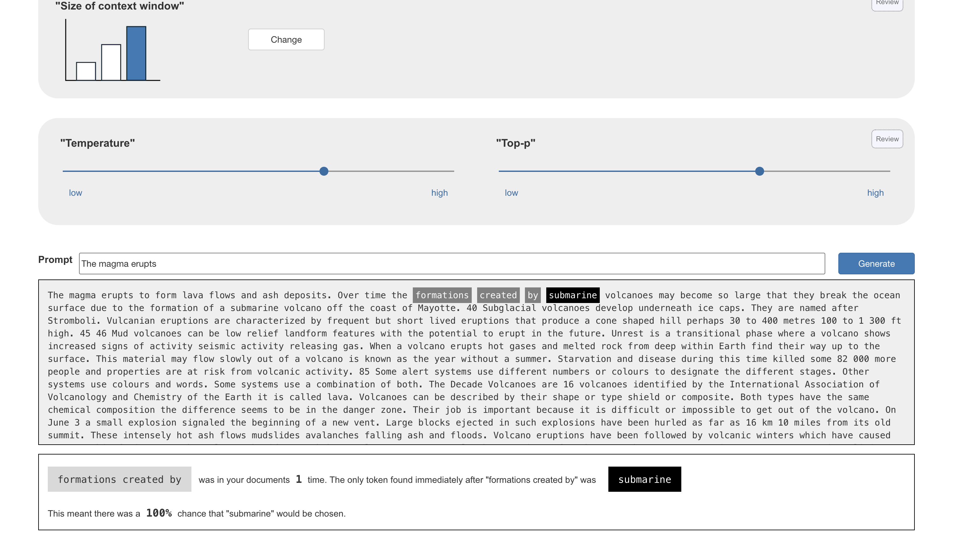  
  
This is taken from the Wikipedia page I added to my corpus.

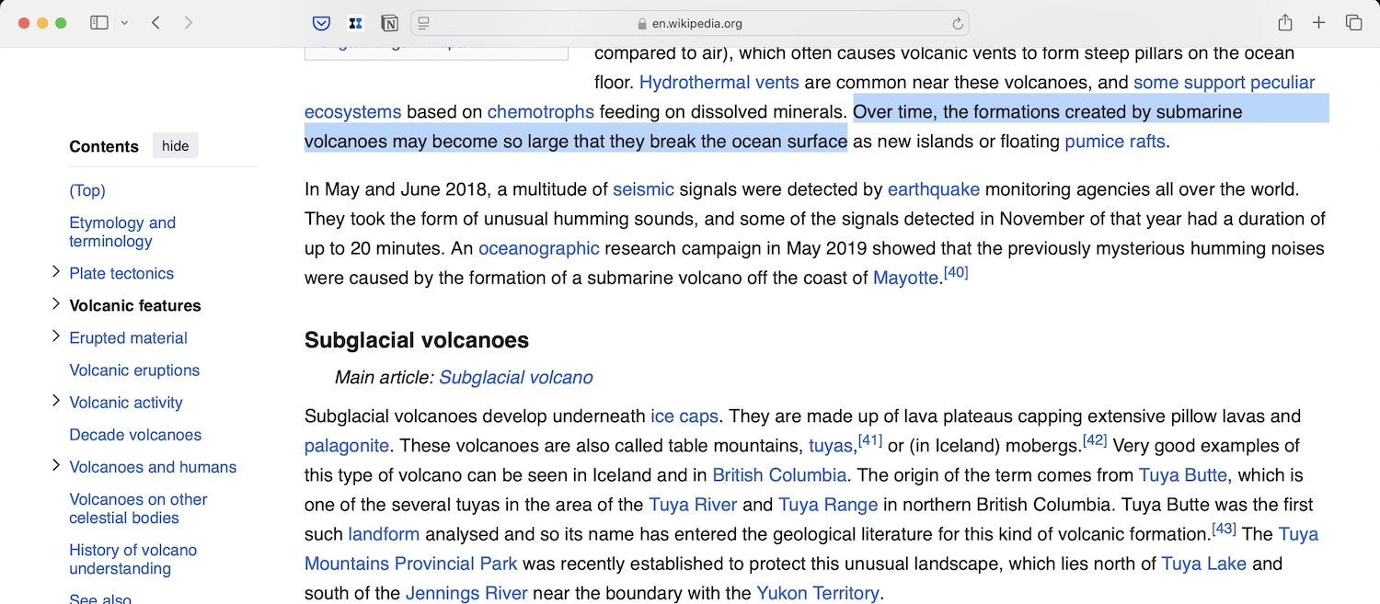

This is because with such a small collection of text, each three-word sequence is found a very small number of times.   
  
You can see this when you click on words.



If a three-word sequence is only found once, the computer only has one option to choose from for the next word.

If this continues, the computer repeats passages from your corpus.

Increasing the length of patterns that the computer is counting improves the text that the computer can generate. But to find enough patterns to generate useful text, you will need a lot more text in the corpus.

1. If you have time, you can add more text to your **corpus** and see if that lets you generate new text with this longer “context window”.

**What next?**

The way that your toy model used “context window”, “temperature”, and “Top-P” values aren’t exactly the same as in real language models. It is similar – and close enough to help you understand the ideas behind them.   
  
In the next stage, you will use a real language model, using real context window, temperature, and Top-P values.

**Stage 2 – Configure a small language model**

1. Click on “**Projects**” on the top menu bar
2. Click the **“+ Add a new project**” button
3. Name your project and set it to learn how to generate text.
4. You should see your new project in the projects list. Click on it.  
   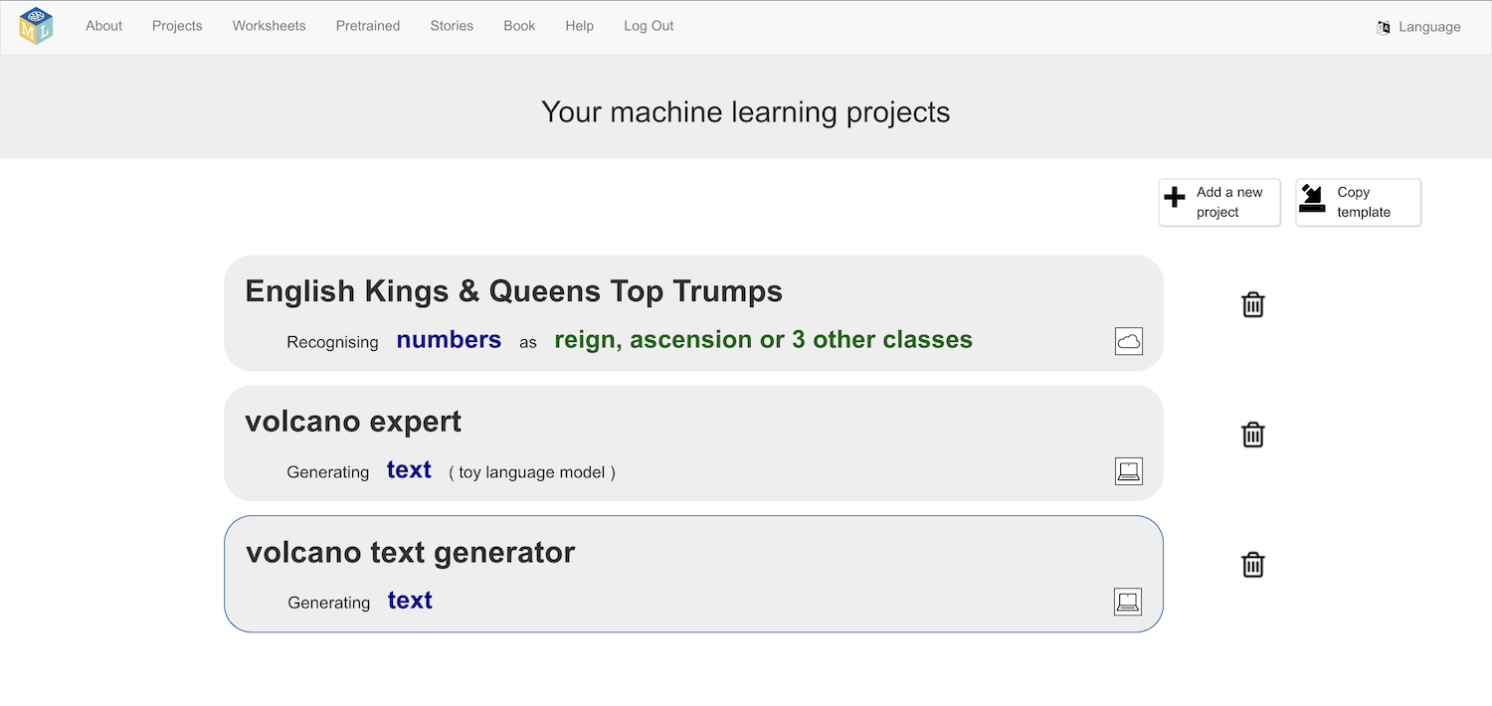
5. Click on **Small** and then click **Next**
6. Choose a model architecture  
   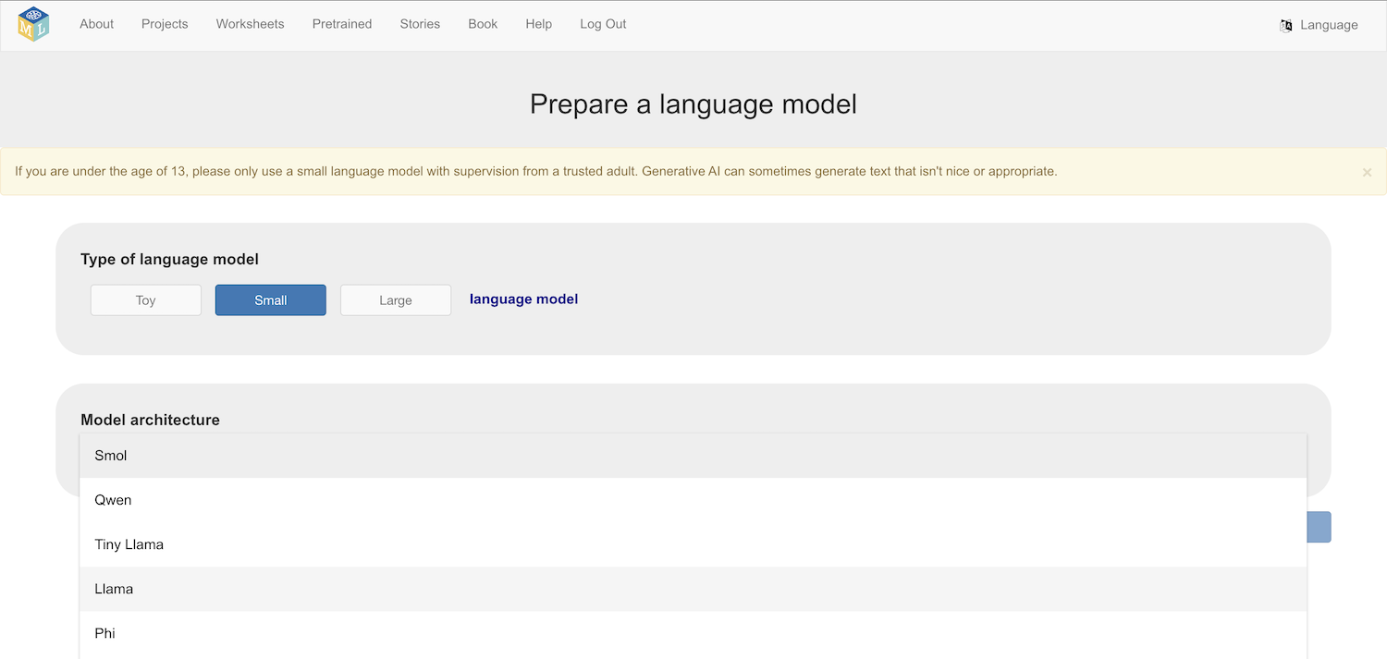  
   *There are multiple models to choose from.   
   “SmolLM2” (made by Hugging Face) – 276 MB download*

*“Qwen 2.5” (made by Alibaba) –289 MB download*

*TinyLlama (made by Singapore Uni. of Technology & Design) – 625 MB download*

*Llama 3.2 (made by Meta) – 711 MB download*

*Phi 1.5 (made by Microsoft) – 806 MB download*

*Gemma 2 (made by Google) – 1.5 GB download*  
*The larger the model you choose, the longer it will take to download and the more storage space it will need on your computer.   
  
The larger models are also more complex to run, and you will need a powerful computer to be able to run them.****Choose a small model such as Smol to start with.***

1. Click **Download**
2. Choose a context window size, and click **Next***Your**toy model used the last 1, 2, or 3 words to choose the next word.   
   Each new word it picked for the end of a sentence had no consideration of the words that were at the start of the sentence – and that produced sentences that made no sense.  
   These small models have been trained using the patterns from millions of documents, so they can use the last hundreds, or even thousands, of words when choosing the next word.   
   It can generate the next word not just based on the words in the current sentence, but in your question and the last answer the model gave before that.*   
   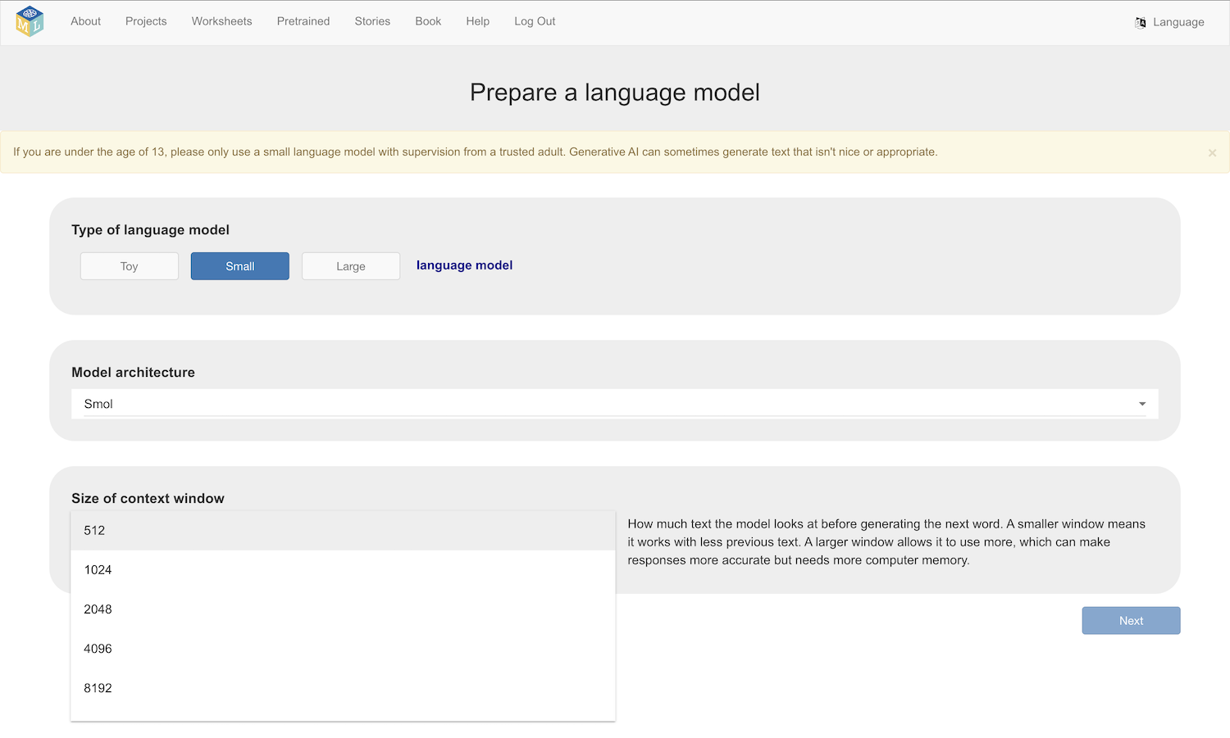
3. Choose temperature and Top-P values using the sliders  
   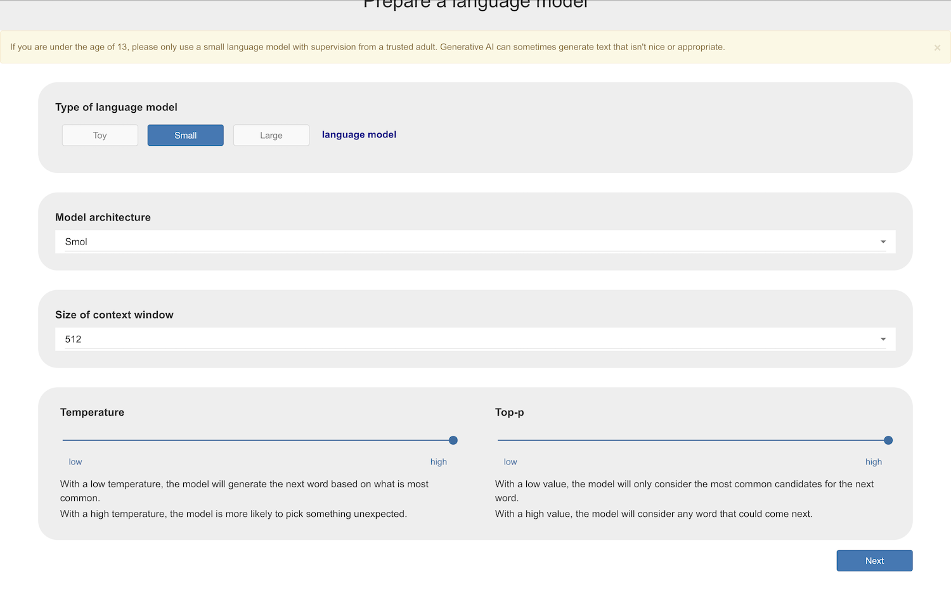
4. Click **Next**
5. Type a question and click **Generate**  
   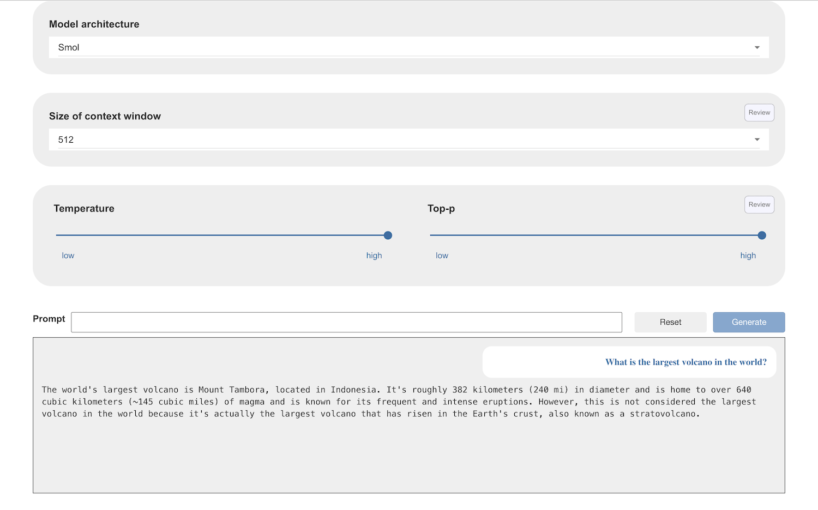
6. Check if the model returns accurate answers to factual or information-based questions  
   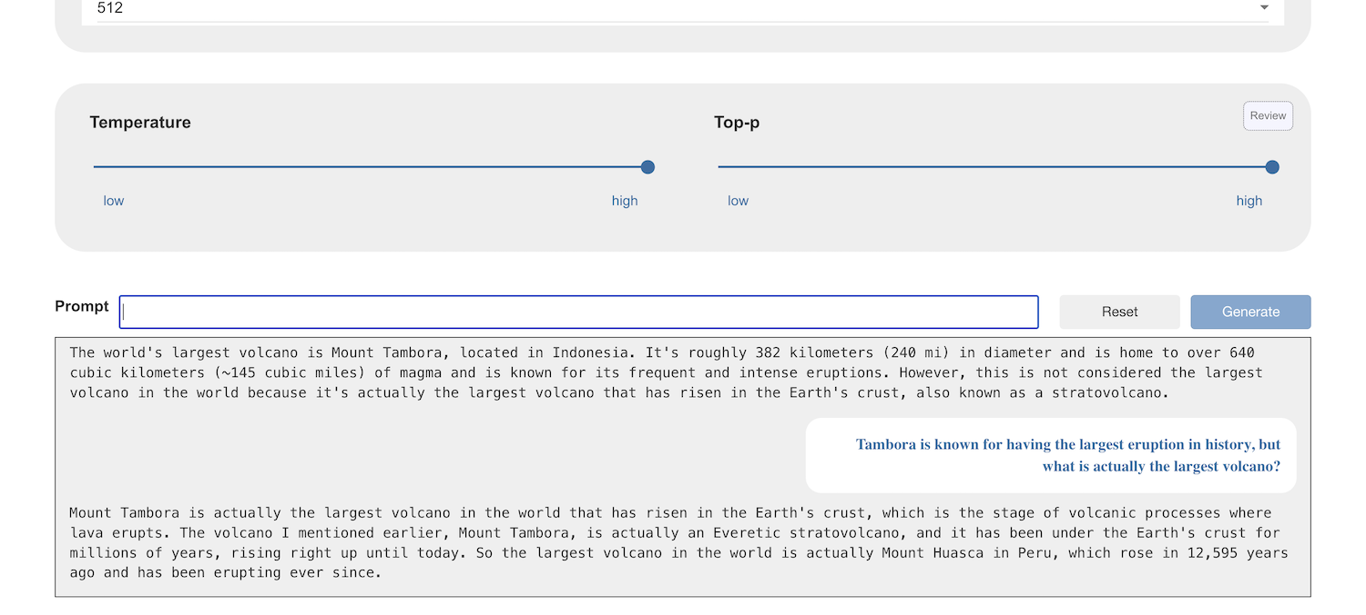
7. Try asking your question to a different model   
   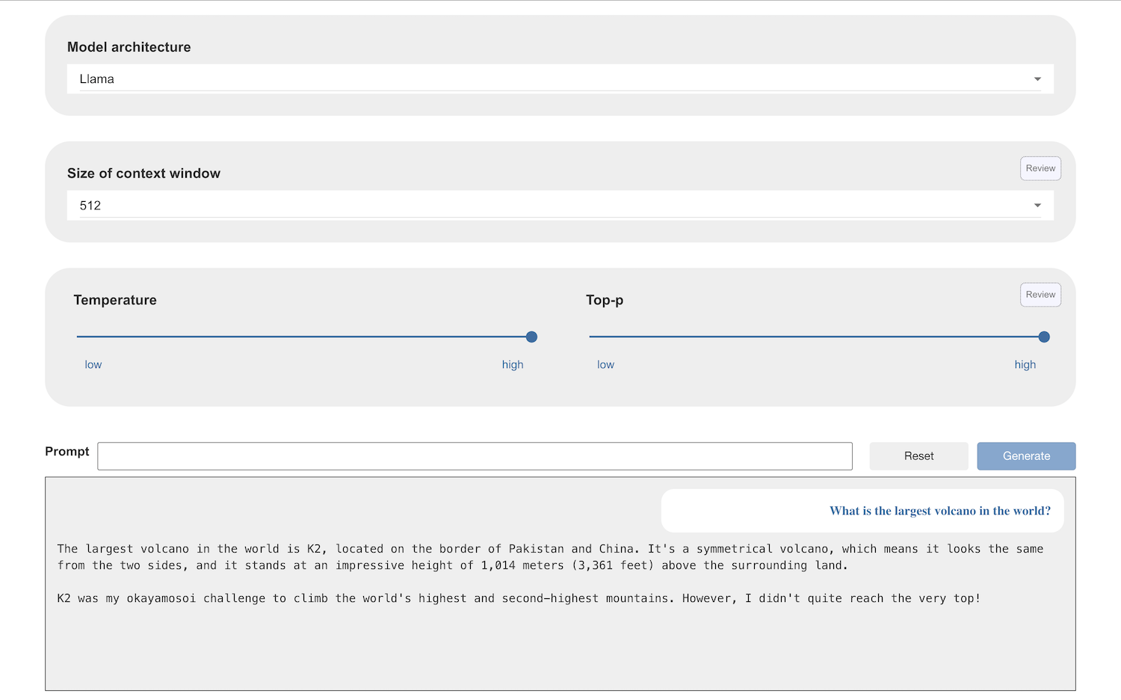   
     
   *Do all models generate the same answers?   
     
   Are they generating accurate answers?*

**Hallucinations**

We ask language models to generate new text, but when it generates statements that aren’t true, we call these “hallucinations”. These are a problem when we use language models in the real world.

Remember that **Temperature** controls the randomness in text generation. With a high temperature, you are increasing the creativity by increasing the chance that less common, less likely words will be chosen.

For factual and knowledge-based questions, creativity isn’t always ideal.

A lower temperature will make the model prioritise the most likely and most probable next words.

A lower Top-P will limit the choices to the next words that are most likely and most probable.

1. Try asking your question with a lower temperature and top-P value  
   *Does this improve the answer that the model gives?*  
   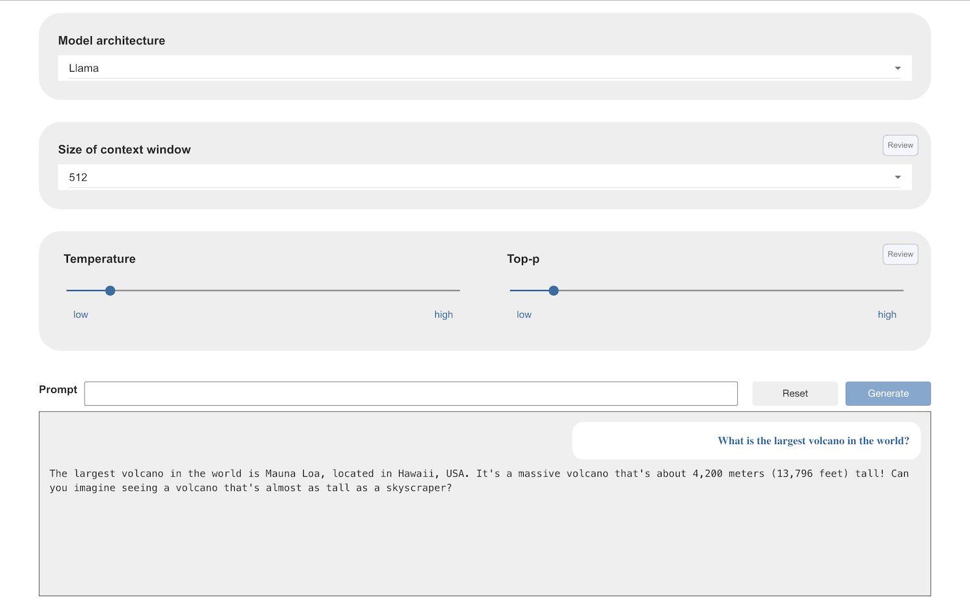
2. Try a creative writing prompt, with a very low temperature & Top-P  
   *I tried “Write me a poem about a volcano”*  
   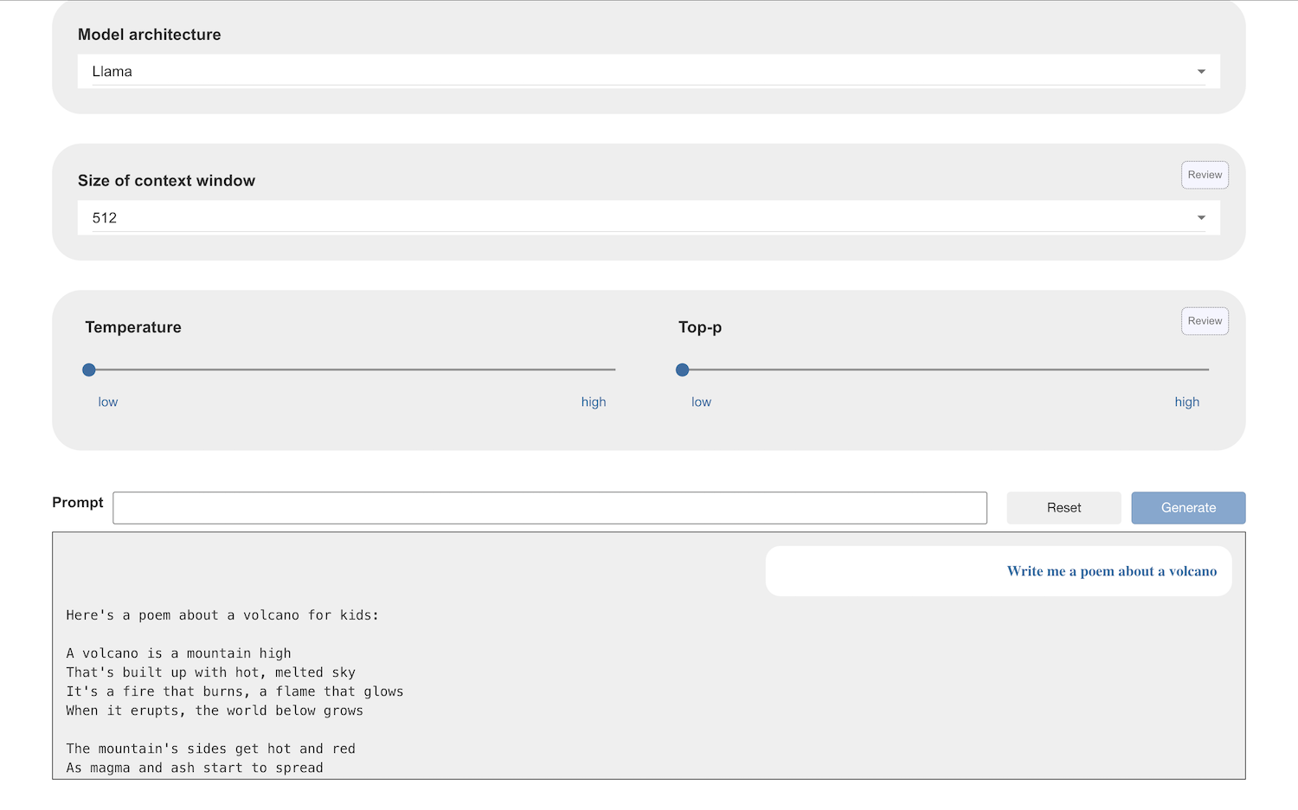
3. Click on **Reset** and then enter the same prompt again  
   *Do you get a very different response?   
   I got an almost-identical poem*
4. Click on **Reset**
5. Increase the temperature and Top-P and try the same prompt again  
   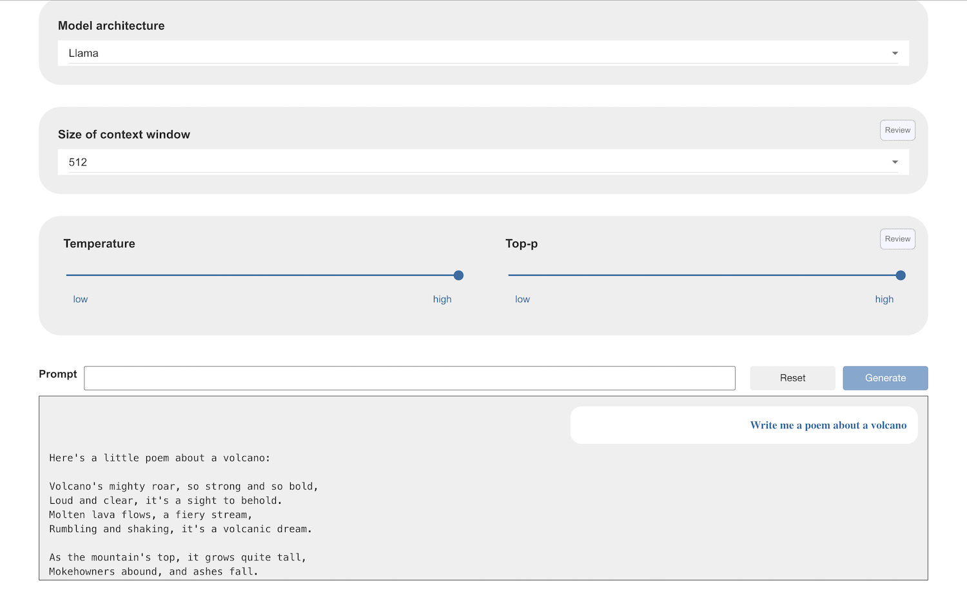
6. Click **Reset** and try that again

**Creativity**

**Temperature** controls the randomness in text generation. With a high temperature, you are increasing the creativity by increasing the chance that less common, less likely words will be chosen.

**Top-P** controls the candidates that your model has to choose from. With a high Top-P, you are increasing the range of words that the model has to choose from.

For creative writing tasks, or tasks where you want the language model to inspire new ideas, this increase in randomness is beneficial.

**Ideas and Extensions**

Now that you’ve finished, why not give one of these ideas a try?

**Try using your language model in Scratch**

Something

**Something else**

Details

**Finally**

Details